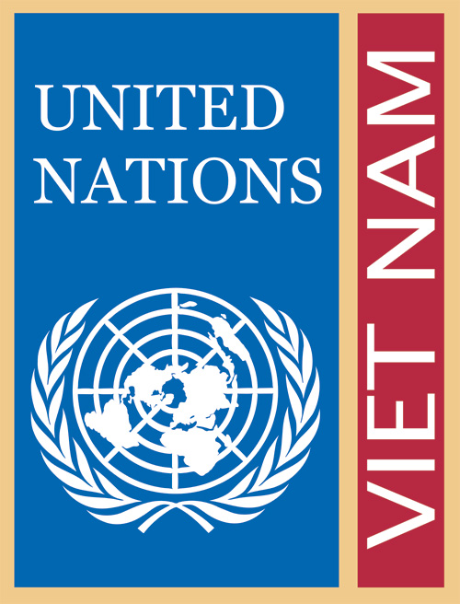
FACTSHEET
COMBATING HUMAN TRAFFICKING
The issue
Human trafficking is a serious violation of human rights. It involves the movement of men, women and/or children by means of deception, coercion or threat for the purposes of exploitation.
The UN in Viet Nam: Working as One
- UN organizations in Viet Nam coordinate their counter-trafficking work through the Technical Working Group on Human Trafficking, part of Programme Coordination Group 1 on social and economic policies. The International Organization for Migration (IOM) currently serves as the facilitator of this group. Other UN agencies active in counter-trafficking work in Viet Nam include ILO, UNICEF, UNODC, and UNESCO. Agencies work via complementary national, bilateral, and regional programmes and projects, including the Interagency Project (IAP) for the Greater Mekong Sub-region.
- The UN’s human trafficking work includes policy advice and support for prevention, protection, and prosecution activities.
- Public sector partners include the National Assembly, MPS, MOFA, MOLISA, MOJ, MPI, the Border Guards Command, the Women’s Union, as well as provincial and local authorities.
UN Technical Working Group on Human Trafficking - Email: Hanoi@iom.int
Vietnamese people vulnerable to trafficking include those that move for work both within and outside of the country. These migrants find jobs as domestic workers, or in the construction, agriculture, fishing and manufacturing sectors, and in the sex industry. Trafficking is known to occur mainly for the purposes of labour and sexual exploitation, but there are also cases of trafficking for marriage and child adoption.
Overseas labour migration is a pillar of Viet Nam’s national development policy. Each year, around 80,000 Vietnamese migrate through regular channels to work abroad, and many more migrate irregularly. These irregular migrants are particularly vulnerable to trafficking, exploitation and abuse. Destinations include South Korea, Malaysia, China, Cambodia and many other countries.
Trafficking of men and boys is an issue that requires more attention. Viet Nam’s penal code was amended in 2010 to recognize male trafficking, but policy implementation and law enforcement remain weak.
Rapid urbanization and economic development continue to drive high internal population mobility within Viet Nam, and internal trafficking is increasingly being recognized as a challenge.
The Government’s response
The Government of Viet Nam is actively responding to human trafficking through a variety of measures, including a new counter-trafficking law currently under debate in the National Assembly. A National Plan of Action for 2004-2010 was implemented, and a new National Plan of Action is being currently finalized with a dedicated budget. Implementation of the National Plan of Action is led by a National Steering Committee with inter-ministerial participation and is supported by Office 130 in the Ministry of Public Security.
Viet Nam also participates in the Coordinated Mekong Ministerial Initiative Against Trafficking (COMMIT), and is considering ratification of the UN Protocol on Trafficking in Migrants (the “Palermo Protocol”).
The UN’s support to fight human trafficking
At the national level, the UN supports the Government of Viet Nam to:
- develop and implement policies and plans on human trafficking, such as national plans of action and guidelines on victim protection;
- draft the new law on trafficking, including through advice and advocacy with the National Assembly and Ministry of Justice;
- strengthen the reception and reintegration system by supporting networking and referrals among service providers and piloting service models with provincial authorities;
- ensure that potential migrant workers and recruitment agencies are able to ensure safe migration, through pre-departure training and the development of an industry code of conduct;
- enhance the capacity of its border control agencies in the detection, investigation and prevention of human trafficking across its national borders;
- improve regional cooperation and exchange of strategic and operational information about human trafficking;
- participate in the COMMIT process and implement bilateral MOUs and standard operating procedures with COMMIT countries; and
- monitor, research and respond to changing trends in trafficking, for example through research on the trafficking of boys.

On the sub-regional and regional levels, the UN:
- traces the origin and veracity of trafficking statistics to separate trafficking myths from trafficking realities in the Greater Mekong Sub-region (GMS), and works to improve the well-being of vulnerable migrants in the GMS and Malaysia through increased protection and targeted assistance;
- facilitates regional tripartite cooperation to prevent trafficking through better recruitment and protection for migrant workers;
- facilitates cross-border cooperation on trafficking issues through the regional Border Liaison Office network;
- strengthens the work of law enforcement agencies in Cambodia, Lao PDR, Thailand and Viet Nam to combat child sex tourism; and
- participates in the COMMIT process through the IAP on human trafficking.
UNITED NATIONS VIET NAM
Address: No. 25 - 29, Phan Boi Chau, Hoan Kiem, Ha Noi | Tel: +84 4 39421495 | Fax: +84 4 3942 2267
Email: info@un.org.vn | Web: http://www.un.org.vn

